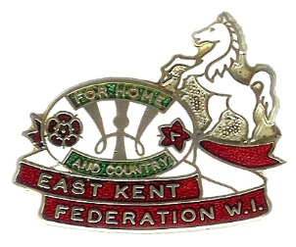

EAST KENT FEDERATION OF WOMEN’S INSTITUTES
Crown House, John Roberts Business Park, Pean Hill, Whitstable, Kent CT5 3BJ
Tel: 01227 464106 Charity No: 219375

PADDLE BOARDING TASTER SESSION

Have you ever wanted to try paddleboarding? Now’s your chance!

Wednesday 27th July at 2.00 pm to 4.00 pm
at Seapoint Canoe Centre, Princes Parade, Hythe CT21 5ZY
£22.50 per person

Join us for a two hour paddleboarding session with full instructions.
All equipment will be supplied but you will need comfortable clothes,
old trainers or swim shoes together with a towel and sun protection.

Spaces are limited so send your ticket application in as soon as possible!

Please fill in the form below and send it together with your cheque for
£22.50 (written in black ink) to the East Kent Federation Office,
Crown House, John Roberts Business Park, Pean Hill, Whitstable, Kent CT5 3BJ

……………………………………………………………………………………….………

Name……………………………….……..… WI…………………………...……………….

Email Address: ………..…………………………………………… Enclosed £ ……….……...

Tickets, further information and a consent form will be sent out by email.
If booking for more than one person please list everyone’s email address overleaf.

