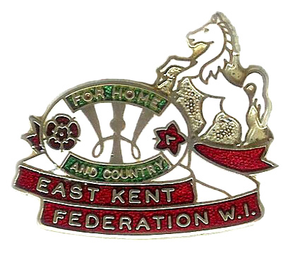

EAST KENT FEDERATION OF WOMEN’S INSTITUTES
Crown House, John Roberts Business Park, Pean Hill, Whitstable, Kent CT5 3BJ
Tel: 01227 464106 email: federation.secretary@eastkentfedwi.org.uk Charity No: 219375

With the winter approaching we invite you to attend a
Zoom Talk

WITHOUT RESERVE

Speaker: Janie Ramsay

The Antiques trade is quite unique with its own rules. This talk takes you behind the scenes of both retail and auction houses. The good, the bad and the really bad are brought into the light.
Our speaker has worked in the trade for over 40 years, including as Director at Sothebys.
There is some audience participation in this talk and promises to be lots of fun!

Tuesday 15TH November 2022 at 14:00

£5 PER PERSON

Please fill in the form below and send to the
East Kent Federation Office with your payments by 25th October 2022
For further information please contact:
Performing Arts, Leisure and Sport Sub-Committee via EKFWI ………………………………………………………………………………………

Name……………………………………W.I…………………………………………

Please PRINT Email address: ……………………………………………………………………..

Contact Tel No: ………………………………………………………………………..
IF YOU DO NOT HAVE AN EMAIL CONTACT PLEASE ENSURE YOU ENCLOSE A SAE

